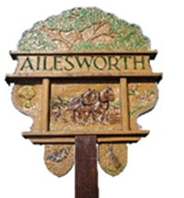

Ailsworth
Annual Parish Meeting
18th May 2026 – 7.15pm
at the Cedar Centre

The Chairman of Ailsworth Parish Council invites residents to attend the Annual Parish Meeting.

AGENDA

7.15pm - Meeting starts
- Introduction and approval of prior year minutes (April 2025)
- Chairmans Report
Formal Meeting concludes
Open Forum – topics for discussion -
- CIL
- Neighbourhood Plan/Housing
Anne Perkins
Anne Perkins – Parish Council Chairman
The Annual Parish Council Meeting to follow along with usual monthly meeting at approximately 7.30pm.

